DIGITAL ASSIGNMENT 2 / REVIEW 2 — FALL 2026

SOFTWARE DESIGN DOCUMENT
Personalized Gym Assistant
A client-side gym management system for members and administrators

Course | Software Engineering
Submitted by | Jayashuriya J (24BAI1058) | Aadhitya Ayyappan (24BAI1080)
Date | September 2026
GitHub | https://github.com/Sambarlasagna/Gym-Assistant

Tech Stack: HTML · CSS · JavaScript · React + Vite · Docker + Nginx

Table of Contents
1. Project Overview ....................................... 3
2. Design Principles Applied .............................. 3
3. High-Level Architecture ................................ 5
4. User Interface Design .................................. 6
5. Design Decisions & Why ................................. 8
6. Maintainability & Future Extensibility ................. 9
7. References ............................................. 10

1. Project Overview
Personalized Gym Assistant is a role-based, client-side web application designed to streamline gym management for both gym members and administrators. Members can view personalized workout plans, diet plans, and gym announcements. Admins can create and manage those plans and publish updates — all from a browser, with no backend server required.
The application is built on a hybrid tech stack: Vanilla HTML/CSS/JavaScript handles navigation, authentication, and dashboards; a React + Vite bundle powers the interactive workout and diet plan interfaces. All state is persisted in the browser's localStorage, making the app fully functional without a backend server.
User Roles
Role | Key Capabilities
Member | Login → Dashboard → View Workout Plans → View Diet Plans → Read Announcements
Admin | Login → Admin Dashboard → Create/Edit Workout & Diet Plans → Post Announcements
2. Design Principles Applied
Four core software design principles were consciously applied throughout the codebase. Each is described below with concrete evidence from the implementation.
2.1 Abstraction
Definition: Complex behaviours are hidden behind clean interfaces. Users of a function or class do not need to know how it works — only what it does.
How we applied it:
- The GymManagementApp class in assets/app.js abstracts all routing, auth-guard logic, and page initialization behind a single object. Any module that wants to navigate simply fires a CustomEvent — it has zero knowledge of routing logic.
- DIET_PLANS and WORKOUT_PLANS constant objects in diet.js and workout.js abstract raw data. UI code loops over them without knowing their internal structure.
Code Snippet:
// GymManagementApp — abstracted routing
handleNavigation(page) {
const routes = {
'dashboard': '../member-dashboard/dashboard.html',
'manage-diet': '../workout-diet/manage-diet.html',
// All routes in one place — callers never hard-code paths
};
if (routes[page]) window.location.href = routes[page];
}

2.2 Modularity
Definition: The system is split into independent, self-contained modules. Each module owns its HTML, CSS, and JavaScript. Adding a new feature does not require touching other modules.
How we applied it:
- auth/ — Login & signup pages only
- member-dashboard/ — Member view only
- admin/ — Admin panel only
- workout-diet/ — Workout & diet pages only
- react-app/ — React components (compiled separately as a Vite bundle)
Each folder is a deployable unit. Removing admin/ would not break member-dashboard/ — they share no code. This directly follows the Single Responsibility Principle.
2.3 Cohesion
Definition: Each module and function does one thing well — all its code is closely related to a single responsibility. High cohesion makes modules easy to understand, test, and debug.
How we applied it:
- diet.js contains only diet-related logic: data constants, create, edit, delete, and render. It does not handle auth, routing, or workouts.
- member-dashboard.js contains only member view logic: membership status display and quick-action card rendering.
- announcements.js handles only CRUD for announcements — nothing else.
Code Snippet:
// diet.js — Everything is diet. Nothing else.
const DIET_PLANS = { /* all diet data */ };

function createDietManagementPage() { /* renders the admin form */ }
function initDietManagementPage(container) { /* wires event listeners */ }
function editDietPlan(planId) { /* edit an existing plan */ }
function deleteDietPlan(index) { /* delete a plan */ }
// Zero workout logic. Zero auth logic. Zero announcement logic.

2.4 Low Coupling
Definition: Modules are loosely connected — they communicate through events or shared data, never through direct function calls across module boundaries. This means any module can be replaced without breaking others.
How we applied it:
- Navigation uses a custom event bus: window.dispatchEvent(new CustomEvent('navigate', { detail: 'manage-diet' })) — diet.js has zero knowledge of routing.
- app.js listens centrally — one listener, one place handles ALL navigation.
- The React bundle is completely decoupled from vanilla JS. It reads/writes localStorage independently and could be replaced without touching any vanilla JS file.
Code Snippet:
// Low Coupling — module fires event, knows nothing about routing
// diet.js:
window.dispatchEvent(new CustomEvent('navigate', { detail: 'manage-diet' }));

// app.js — single central listener handles ALL navigation
window.addEventListener('navigate', (e) => this.handleNavigation(e.detail));

3. High-Level Architecture
3.1 Architectural Style: Client-Side MVC-Lite
The application follows a "Client-Side MVC-Lite" pattern — a simplified Model-View-Controller approach adapted for a zero-backend, localStorage-driven environment. A separate React Component Layer handles the most interactive UI sections (workout and diet plan viewers).
MVC Role | Maps To | Files
Model | Browser localStorage JSON stores | Keys: currentUser, dietPlans, workoutPlans, announcements
View | HTML pages + dynamic DOM + React components | auth/*.html, member-dashboard/*.html, react-app/src/
Controller | GymManagementApp class + per-module JS | assets/app.js, diet.js, workout.js, admin-dashboard.js
3.2 Architecture Diagram
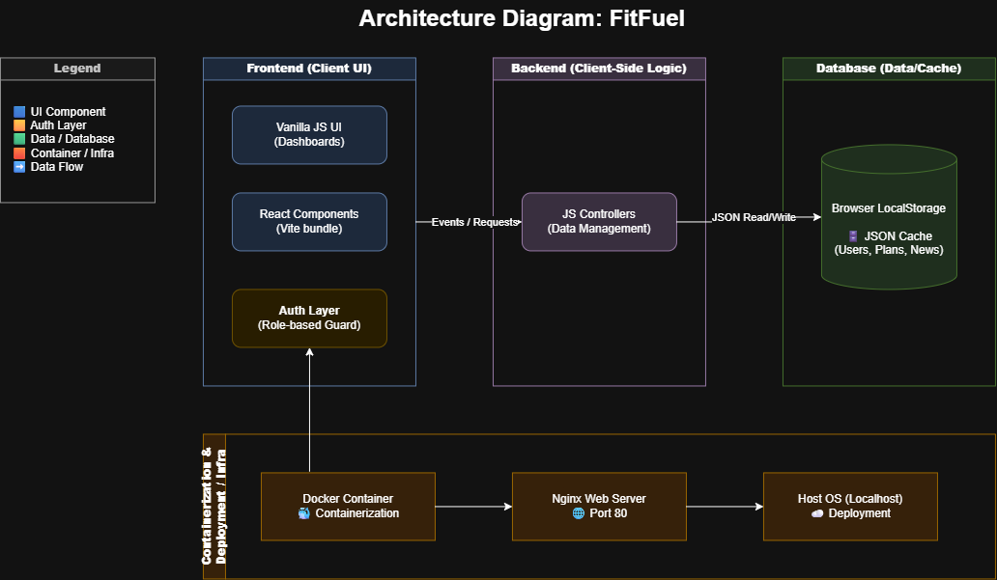
Figure 1 — Architecture Diagram: Personalized Gym Assistant
3.3 Why This Architectural Style?
- No backend needed: localStorage provides sufficient persistence for a learning/demo project — zero infrastructure cost.
- Role separation: The Auth Layer enforces role-based access at the routing level (in app.js), not inside individual views. Clean and centralized.
- Hybrid rendering: Static HTML for fast-loading auth/dashboard pages. React used only where its component model genuinely helps.
- Docker + Nginx: Containerization ensures the app runs identically on any machine and demonstrates production-readiness.
3.4 Data Flow
User Action → HTML Page → JS Controller (app.js / module JS)
→ Read / Write localStorage
→ DOM Update OR Page Redirect → User sees updated UI

Auth flow: login.html → auth JS → localStorage.setItem('currentUser') → redirect
Admin flow: manage-diet.html → diet.js → localStorage('dietPlans') → reload
React flow: workouts.html → React bundle → localStorage('workoutPlans') → re-render

4. User Interface Design
The UI follows a consistent design language: a dark navy navbar (#0c2435) with clay-orange accents (#d96c2f) and a warm sandy background (#f6f1e9). This palette is energetic and professional — appropriate for a fitness application.
Design Choices for User-Friendliness
- Role-based navigation: Members and Admins see different nav links — users are never shown options they cannot use.
- Card-based layout: Information is grouped in cards with clear headings for easy scanning.
- Color-coded importance: Red/yellow borders on announcements instantly communicate urgency without reading.
- Tab/filter controls: Goal-based filtering (Weight Loss / Muscle Gain / Endurance) lets members find relevant plans without scrolling.
- Admin-only controls: Create/Edit/Delete buttons are rendered only when isAdminUser() returns true.
Screen 1 — Login / Auth Panel
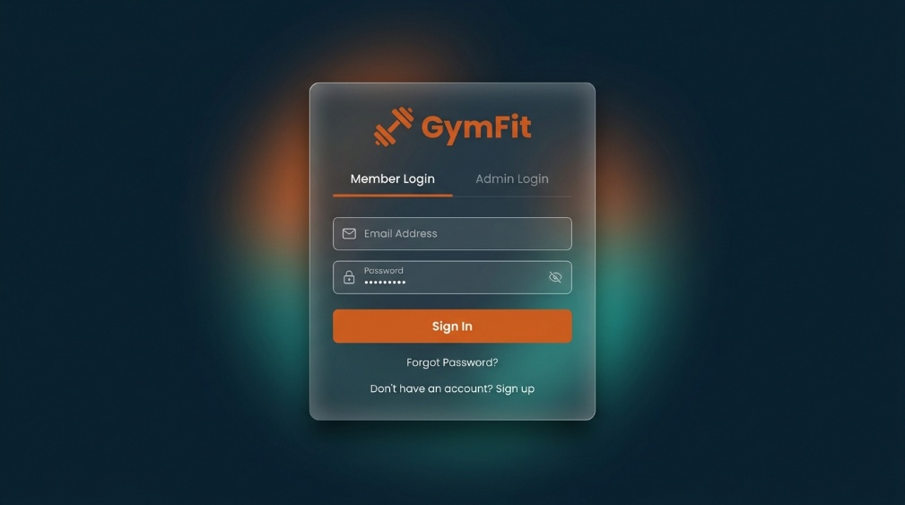
Figure 2 — Screen 1 — Login / Auth Panel
Description: The login page uses a centered glassmorphism card on a dark navy background. Two tabs allow role switching between Member and Admin login without navigating to a different page. The orange "Sign In" CTA is prominent. A "Sign up" link is available for new members.
Screen 2 — Member Dashboard
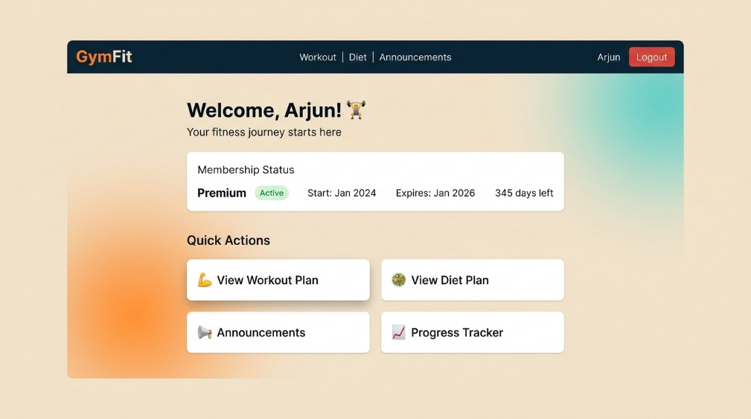
Figure 3 — Screen 2 — Member Dashboard
Description: The member dashboard shows a personalized welcome header with the member's name. A membership status card displays plan type, active/expired badge, start date, expiry date, and days remaining. Four quick-action tiles provide one-click navigation to Workout Plans, Diet Plans, Announcements, and a Progress Tracker placeholder.
Screen 3 — Workout Plans
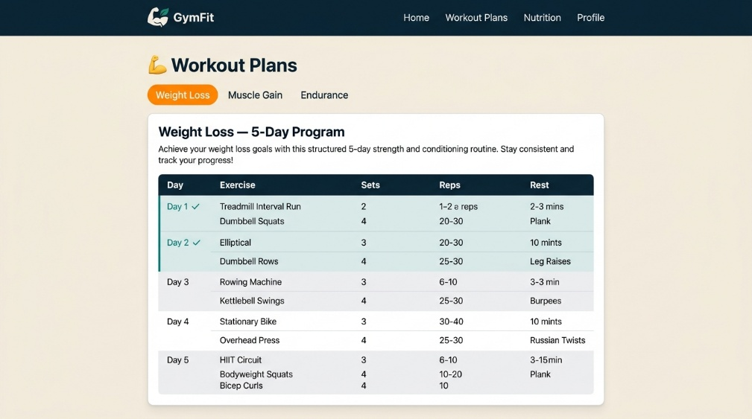
Figure 4 — Screen 3 — Workout Plans
Description: The workout plans page features three tab buttons (Weight Loss, Muscle Gain, Endurance) for quick goal-based filtering. The active plan is displayed as a card with a structured HTML table showing Day, Exercise, Sets, Reps, and Rest columns. Completed days are tinted in teal.
Screen 4 — Diet Plans
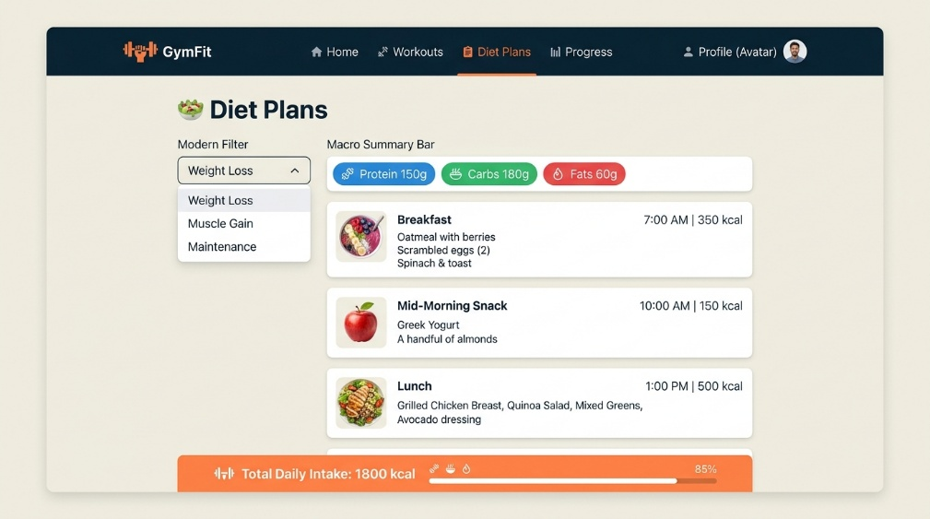
Figure 5 — Screen 4 — Diet Plans
Description: The diet plans page shows a goal-filter dropdown at the top followed by a macro summary bar (Protein / Carbs / Fats in colored badges). Below are individual meal cards for each part of the day — each showing meal type, time, calorie count, and food items. A sticky footer banner shows the total daily intake.
Screen 5 — Gym Announcements
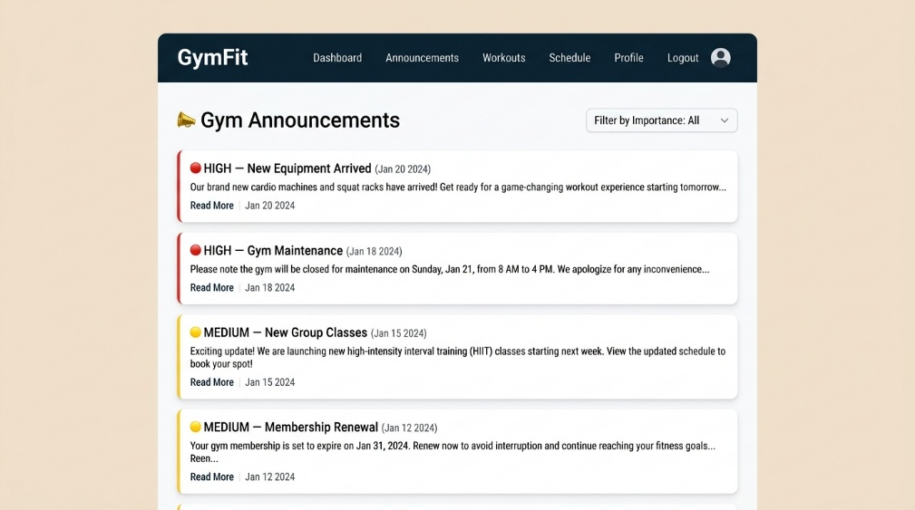
Figure 6 — Screen 5 — Gym Announcements
Description: The announcements page lists gym updates newest-first. Each card has a colored left border: red for HIGH importance, yellow for MEDIUM. A filter dropdown at the top lets members view only high-priority items. Date and content preview are shown on each card.
Screen 6 — Admin Dashboard
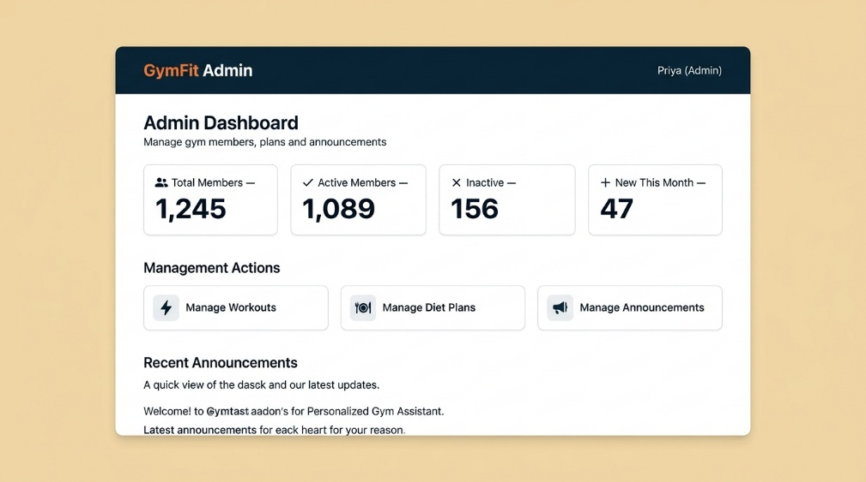
Figure 7 — Screen 6 — Admin Dashboard
Description: The admin dashboard shows four stat counters (Total Members: 1,245 / Active: 1,089 / Inactive: 156 / New This Month: 47). Below are three clickable management action cards — Manage Workouts, Manage Diet Plans, Manage Announcements. A recent announcements preview list appears at the bottom.

5. Design Decisions & Why
Decision 1 Hybrid Vanilla JS + React Architecture
What: Core pages (auth, dashboards, announcements) use plain Vanilla JavaScript. Workout and diet plan pages use React + Vite compiled components.
Why: Vanilla JS requires zero build tooling and loads instantly — perfect for simple CRUD pages. React's component model shines for the data-heavy, filterable plan UIs where re-rendering and state management would be verbose in plain JS. This hybrid avoids over-engineering simple pages while getting React's power where it genuinely helps.
Decision 2 localStorage as the Sole Data Store
What: All user data, plans, and announcements are stored in localStorage as JSON. No backend, no database, no API calls.
Why: This makes the app fully portable — it runs from a local file, GitHub Pages, or Docker with zero server dependency. For a learning/demo project, a backend would be disproportionate. The trade-off (device-local data) is acceptable and clearly documented in the README.
Decision 3 Centralized Role-Based Routing in app.js
What: The GymManagementApp class is the single controller for all route guards and navigation. Individual modules fire CustomEvent('navigate') — they never redirect themselves.
Why: A single routing controller means access control is enforced in exactly one place. Adding a new protected route requires one line change in app.js — not changes scattered across many files. This enables future migration to a proper router library without touching module-level code.
Decision 4 Module-per-Feature Folder Structure
What: The repository is organized into feature-based folders: auth/, member-dashboard/, admin/, workout-diet/, react-app/.
Why: This structure scales — a developer finds everything related to the admin panel inside admin/ without searching the whole repo. New features can be added as new folders without modifying existing ones. This directly supports the Open/Closed Principle — open for extension, closed for modification.
Decision 5 Docker + Nginx for Deployment
What: A Dockerfile wraps the static files in an Nginx container. docker run -p 8080:80 gym-assistant serves the full app on port 8080.
Why: Containerization ensures the app runs identically on any machine regardless of OS or local tooling. It prepares the project for real-world deployment patterns (cloud VMs, Kubernetes, CI/CD pipelines). Nginx is ideal for serving static assets with correct MIME types and efficient caching headers.

6. Maintainability & Future Extensibility
The design was intentionally structured to allow the following extensions without modifying existing working code:
Future Feature | How Current Design Supports It
Add a real backend / database | Replace localStorage read/write in module JS files with API calls — the UI layer does not change at all
Add new member feature (e.g. Progress Tracker) | Create new progress/ folder, add one entry to routes in app.js — zero changes to other modules
Add password hashing | Auth logic is isolated in auth/ — replace the localStorage check in one place only
Replace Vanilla JS pages with React | The CustomEvent navigation contract stays the same — React components fire the same navigate events
Multi-language (i18n) support | All display strings are in HTML templates / JS template literals — extract to a language object
7. References
[1] Martin, R. C. (2008). Clean Code: A Handbook of Agile Software Craftsmanship. Prentice Hall.
[2] Gamma, E., Helm, R., Johnson, R., & Vlissides, J. (1994). Design Patterns: Elements of Reusable Object-Oriented Software. Addison-Wesley.
[3] React Documentation — Thinking in React. https://react.dev/learn/thinking-in-react
[4] MDN Web Docs — Web Storage API (localStorage). https://developer.mozilla.org/en-US/docs/Web/API/Window/localStorage
[5] GitHub Repository — Gym-Assistant. https://github.com/Sambarlasagna/Gym-Assistant
[6] Architecture Diagram (editable source): docs/design/architecture.drawio

